# Stakeholders

* Workshop attendees (end users)
* Clients
* Workshop employees
* Parents of attendees

# User Stories

As a **workshop attendee**, I want to be I want to enjoy playing the game so that I have a good time.

As a **client**, I want to give an interactive app to the attendees so that I inspire future generations to pursue careers in STEM.

As a **workshop employee**, I want to be able to easily explain the app to the attendees so that they can use it independently after the workshop is over.

As a **parent**, I want my kids to figure out if their interests are in STEM so that they can work out their path they want to take in life.

# Functional and Non-Functional Requirements

1. Non-functional, good
2. Functional, good
3. Functional, bad
4. Functional, good
5. Functional, good
6. Non-functional, bad (needs to be broken into parts)
7. Non-functional, bad (needs to be more specific)
8. Non-functional, good
9. Non-functional, good

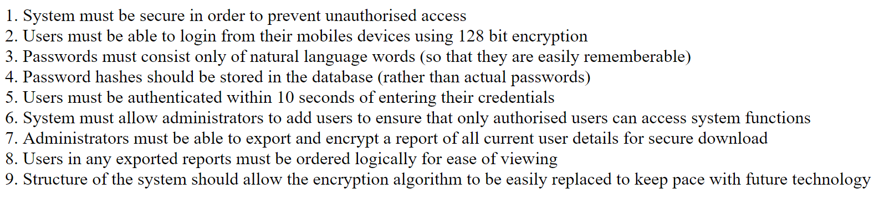

# Client Based Requirements:

1. Playable game for their outreach group

- Game needs to be easy to learn and play, but challenging enough to encourage replay-ablity

- Non-functional, bad requirement

- Could replaced with several accessibility options

1. Possibly 3D, wouldn’t mind 2D

- Game could run using a 3D game engine that we know how to use and is allowed to be used by module standards

- Functional, Good requirement

1. Usable controls

- Game controls are functional and ergonomic.

- Non functional, Good requirement

1. Display Research (incorporate)

- Snippets of research are to be incorporated into the game (no exact method of how- to our discretion)

- Non-functional, good requirement

1. Mobile

- Must be built on Android to support mobile application specification

- Functional, good requirement

- However, can be interpreted as being compatible (or even good for a mobile experience- i.e. how well it runs on mobile devices, or how the game controls play on devices)